Overview Report
The overview report is a headline report showing activity over a specific amount of time. The time period can be adjusted. You will see:

- Screen views (by screen and total) – any page that is not a specific document. This can be a segment, folder, product, search screen, etc.
- Asset views (by asset and total) – shows views of assets (videos/office docs/pdfs) by both name and type.
- Email Shares by User (by user and total) – shows the most active users by email shares.
- Asset Views by User (by user and total) – shows the most active users by asset views.
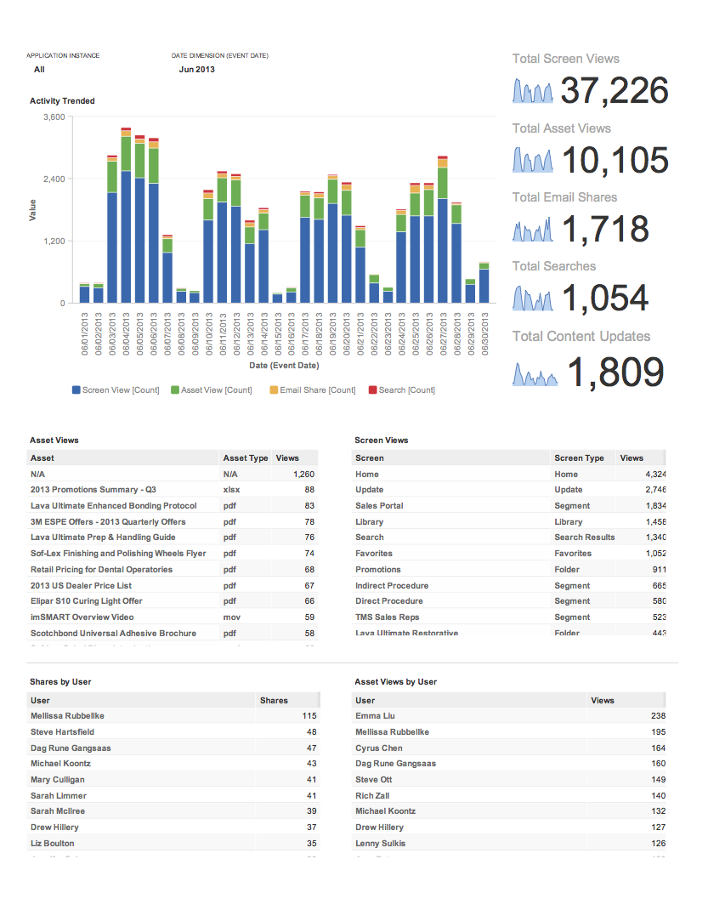

Top Users
Top users report is a headline report for the most active users. This shows the most active users by specific activity as well as a “leaderboard” of users.
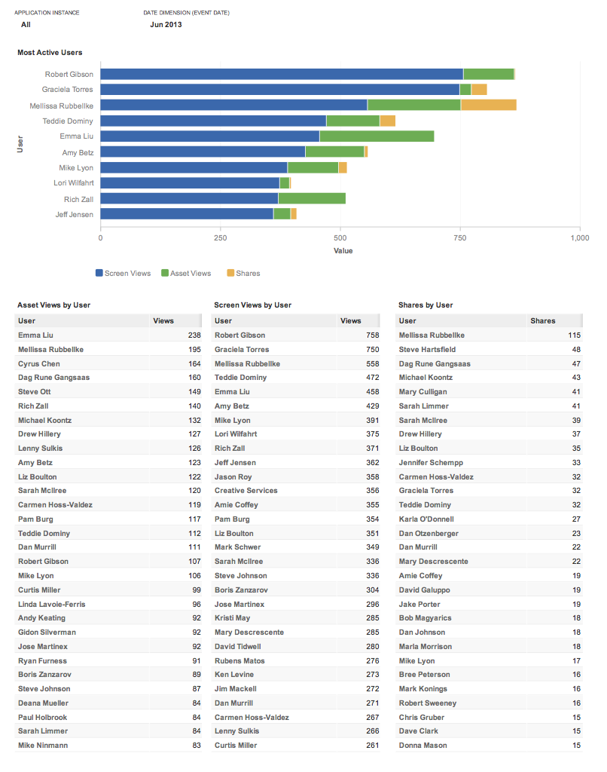

Activity by User
The Activity by User report is much like the overview report, except the content is filtered by one or more users. The report below shows all the activity in June for Jason Roy. You will notice:
- Asset views
- Screen views
- Asset shares
- Asset prints

